README file

Spotify 2024 Streaming data

1. Data Pre-processing
The initial step involved cleaning and organizing the data to ensure accuracy and consistency. This included:
- Checking for and correcting all spelling errors across datasets.
- Creating normalized tables for Albums, Artists, and Countries to enhance data structure.
- Removing duplicate entries to maintain data integrity.
- Establishing primary keys in each supporting table.
- Adding corresponding foreign keys in the main fact table to enable relationships.
- Converting all relevant datasets into proper data table formats.
- Performing a thorough review to verify data consistency.

2. Data Modelling
Once pre-processing was complete, a structured data model was created.
- Relationships were defined between the fact table and dimension tables using primary and foreign keys.
- A series of DAX measures and calculated columns were developed to support the report's analytical needs:
  - A measure was created to calculate the number of countries each artist is streamed in.
  - A calculated column labelled "International Singer" was added to indicate whether an artist was streamed in more than two countries.
  - An average skip rate measure was implemented to analyse genre-based skip behaviour.
  - A measure was introduced to summarize total streaming hours per artist.
  - A measure to compute average stream duration (in minutes) was also created, handling blank values appropriately.
  - A measure to count the number of unique artists was added using distinct artist keys.
Type | Name | Formula
Measure | Number of Countries per Artist | CALCULATE(DISTINCTCOUNT('Spotify 2024 streaming data'[Country Key]), ALLEXCEPT('Spotify 2024 streaming data', 'Spotify 2024 streaming data'[Artist Key]))
Calculated Column | International Singer | IF([ArtistCountryCount] > 2, "Yes", "No")
Measure | Avg Skip Rate by Genre | CALCULATE(AVERAGE('Spotify 2024 streaming data'[Skip Rate (%)]), ALLEXCEPT('Spotify 2024 streaming data', 'Spotify 2024 streaming data'[Genre]))
Measure | Total Hours by Artist | CALCULATE(SUM('Spotify 2024 streaming data'[Total Hours Streamed (Millions)]), ALLEXCEPT('Spotify 2024 streaming data', 'Spotify 2024 streaming data'[Artist Key]))
Measure | Average Stream Duration (Min) | VAR Result = AVERAGE('Spotify 2024 streaming data'[Avg Stream Duration (Min)]) RETURN IF(ISBLANK(Result), 0, Result)
Measure | Number of Artists | DISTINCTCOUNT(Artists[Artist Key])
Final data model:
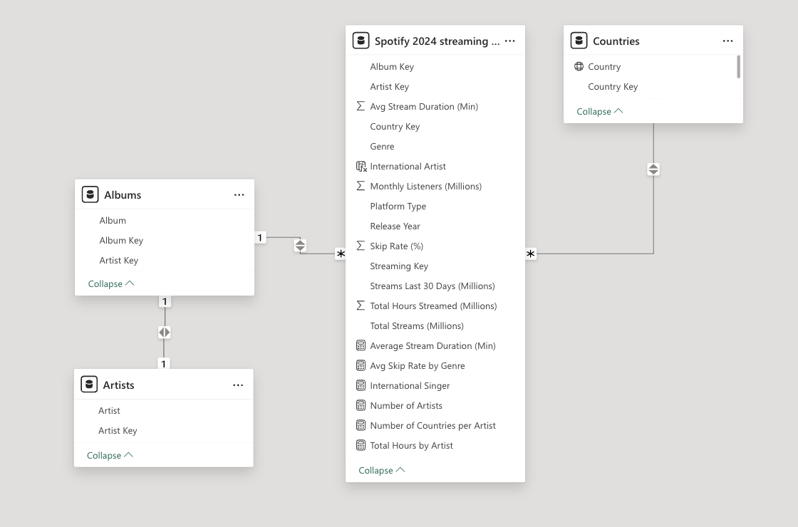

3. Report Creation
The Power BI report was developed over multiple pages to present insights clearly and interactively.
- Page 1 features two KPI tiles showing the number of artists and the average stream duration. It also includes:
  - A bar chart displaying monthly listeners per artist.
  - A shaded line chart visualizing the average skip rate (in seconds) by genre.
  - A slicer allowing filtering by country.
- Page 2 displays:
  - A map chart with bubble sizes representing total yearly streams per country.
  - Two slicers for filtering by genre and artist.
- Pages 3 and 4 serve as tooltip pages:
  - Page 3 includes a table (Country, Total Streams) used as a tooltip for the map chart.
  - Page 4 contains a donut chart showing the number of streams per artist, used as a tooltip for the bar chart on Page 1.
- A drill-down table was created to show artist, country, 30-day stream totals, and annual stream totals. This table is linked to the monthly listeners bar chart via drill-through functionality.
- Report interactivity was carefully managed:
  - KPI tiles were protected from being influenced by slicer selections.
  - The Selection Pane was used to organize visuals, and tab order was refined for a better user experience.
- A bookmark was created specifically for the "Argentina" country view, enabling quick access.
Example of a tooltip:
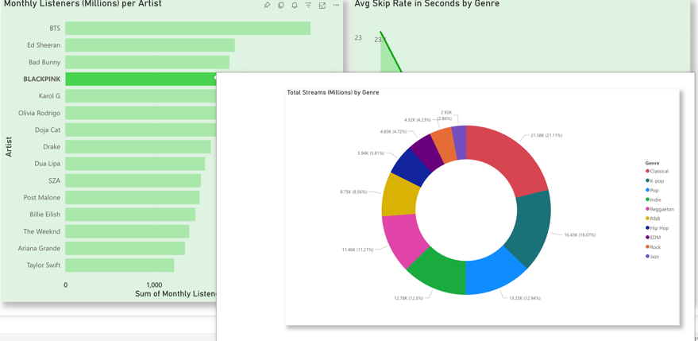

4. Visualization & Formatting
Visual consistency was maintained throughout the report by:
- Applying a uniform colour theme and formatting style.
- Adding background colours and shading to key figures and charts to enhance readability and emphasis.
Example of Page 1 – Overview. The whole file will be attached.
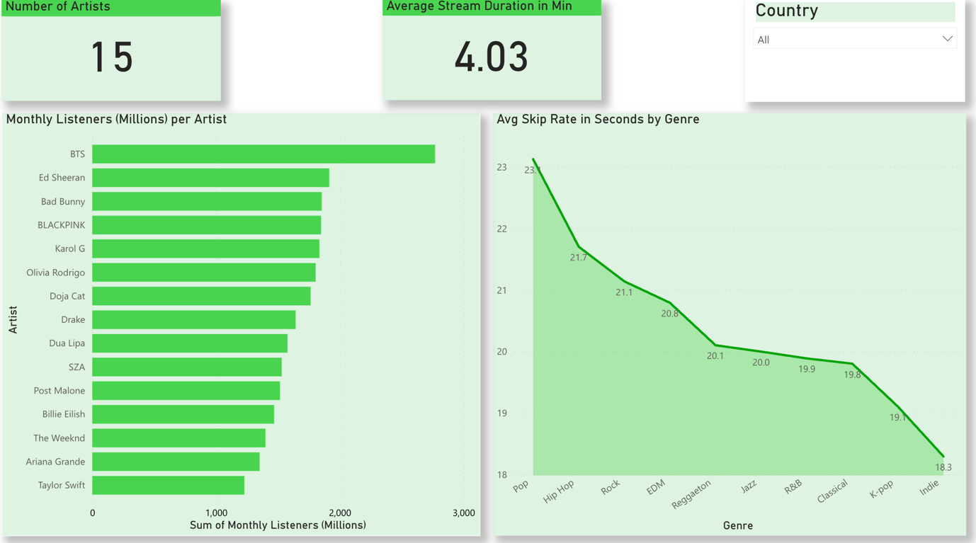

5. Data insights

Based on the 2024 Spotify streaming dataset, the following insights have been identified. These represent key trends, but are not exhaustive.

- Artist Trends
- BTS leads the analysed artists in both total stream hours and monthly listeners, indicating strong global fan engagement.

- Genre Popularity by Region
- Rock records its highest number of streams in Turkey, suggesting a regionally strong listener base.
- K-Pop is most streamed in Argentina, pointing to a concentrated market for Korean music in South America.

- Listener Behaviour
- Pop has the lowest skip rate, with listeners skipping after an average of 23.1 seconds, indicating higher early retention.
- Indie is skipped fastest, at an average of 18.3 seconds, suggesting lower initial engagement.

